Mechanical Overview

Year: _2021_ Semester: _Spring__ Team: _16__ Project:_Smart Conveyor Belt System___

Creation Date: ___2/18/2021____________ Last Modified: 2/19/2021 Author: _______Ryan Eastman____________ Email:________reastman@purdue.edu_

Assignment Evaluation:

|  |  |  |  |  |
| --- | --- | --- | --- | --- |
| **Item** | **Score (0-5)** | **Weight** | **Points** | **Notes** |
| **Assignment-Specific Items** | | | | |
| **Commercial Packaging Analysis 1** |  | x2 |  |  |
| **Commercial Packaging Analysis 2** |  | x2 |  |  |
| **CAD Model Illustrations** |  | x4 |  |  |
| **Project Packaging Specifications** |  | x2 |  |  |
| **PCB Footprint Layout** |  | x2 |  |  |
| **Writing-Specific Items** | | | | |
| **Spelling and Grammar** |  | x2 |  |  |
| **Formatting and Citations** |  | x1 |  |  |
| **Figures and Graphs** |  | x2 |  |  |
| **Technical Writing Style** |  | x3 |  |  |
| **Total Score** |  | | |  |

5: Excellent 4: Good 3: Acceptable 2: Poor 1: Very Poor 0: Not attempted

Comments:

*Comments from the grader will be inserted here.*

1. Commercial Product Packaging
   1. Product #1

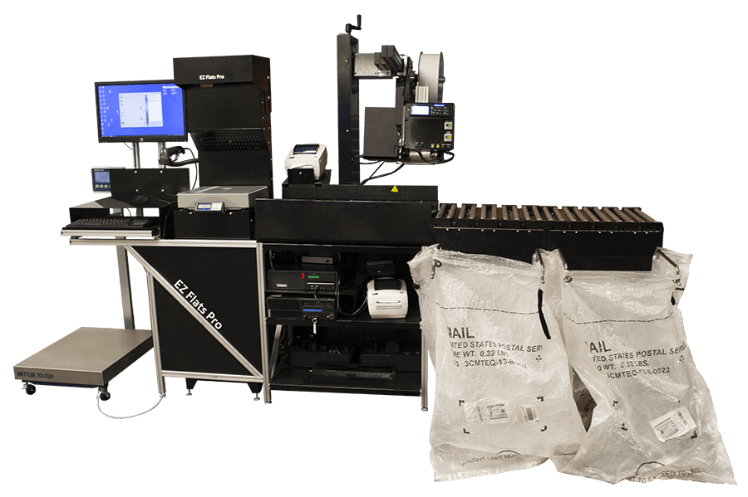

EZ Flats Pro by Engineering Innovation is a solution created here in Lafayette. This is a mail and parcel sorting system using rollers to move the packages. It’s designed so the package gets scanned as it’s coming along the system. The operator is then meant to pick the package up by hand and sort it. The design is meant to assist humans not fully automate the package sorting. It relies on rollers which have minimal maintenance. Our system will use barcode scanners as well but instead of rollers we’re using a conveyor belt for speed and instead of relying on human intervention ours will direct the packages to the correct placements.

* 1. Product #2

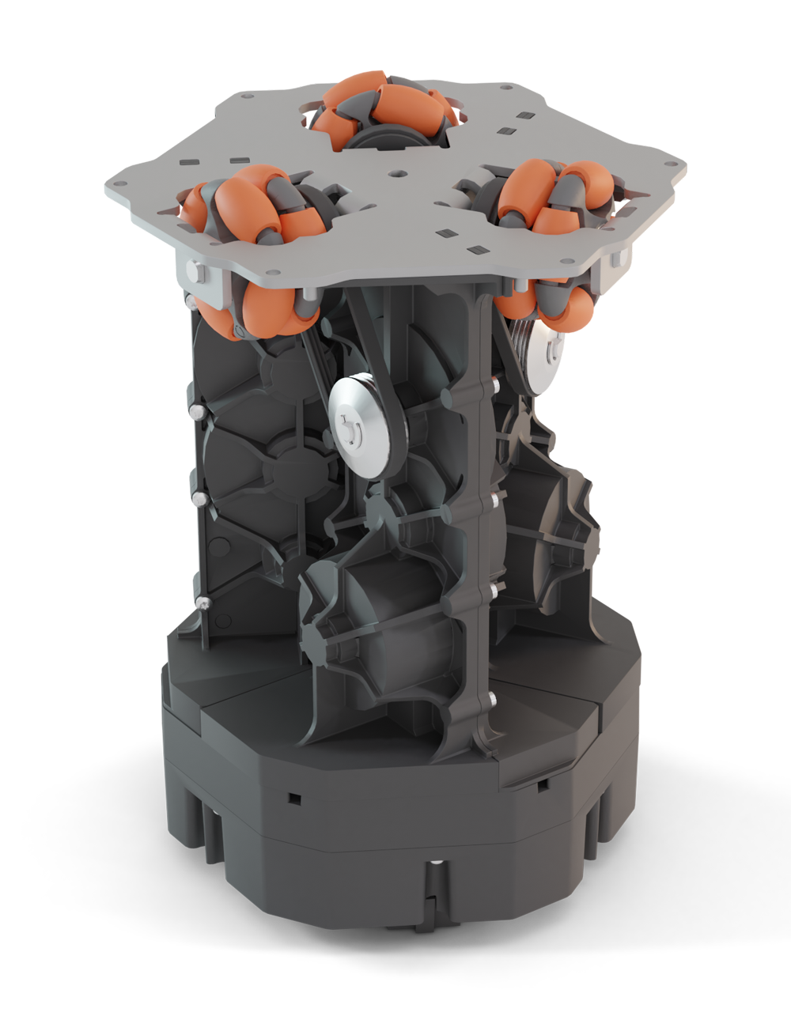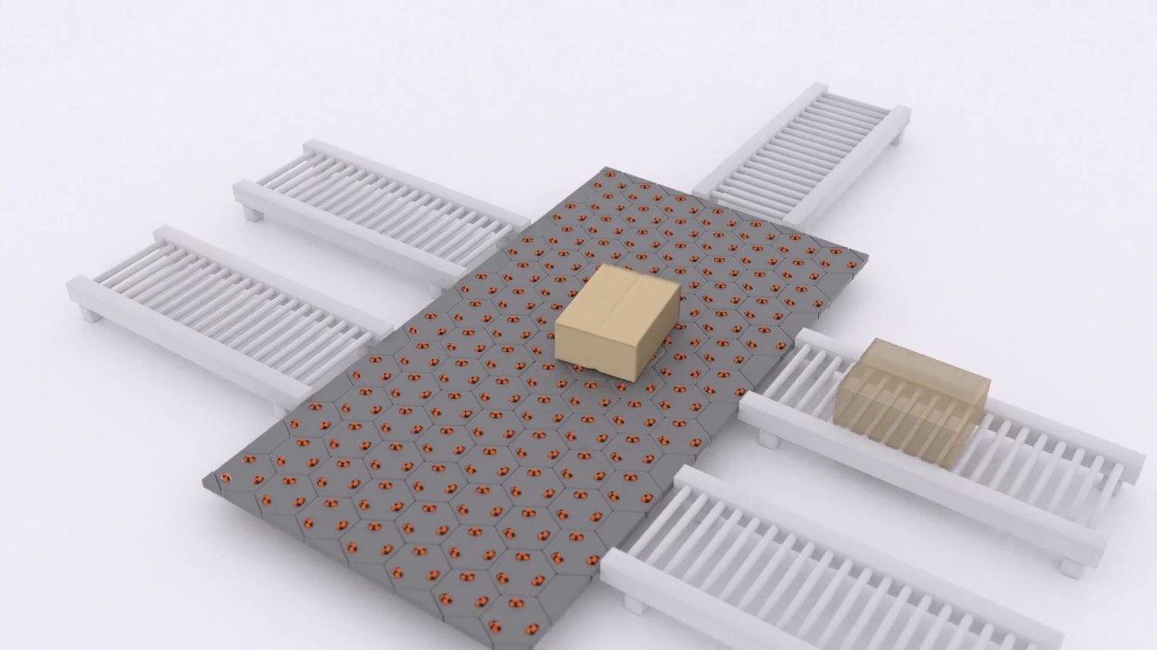

Celluvayor by Cellumation is a package movement solution that uses a cell based design to be expandable to whatever needs. It moves the packages wherever they need to by moving along motorized wheels until the package goes where it needs to. This has several advantages, it’s expandable, it’s omnidirectional and it does not rely on gravity. This design does have some downsides, maintenance effort can be high due to the large number of moving parts and pieces. Cost can be very high as well as it takes many cells for large package platforms. Our system includes a way to retrieve information from the packages as well as moving them. In addition ours will move packages quicker as each wheel on the celluvayor has a relatively small motor. Our design has another advantage over the complex cell design in that if a part fails it’s easy to identify and replace without more than a little disruption to the machine. Maintenance such as oil and inspections is easier to perform on our design as well. And finally our design is much cheaper with no proprietary materials.

3.0 Sources Cited

*Throughout this and other papers, use of the IEEE citation style should be used. Use of embedded hyperlinks for all web-based sources is required. A reference to the IEEE citation style format is provided* [*here*](http://www.ieee.org/documents/ieeecitationref.pdf)*.*

[4] cellumation. 2020. *Celluveyor - Cellumation*. [Online] Available at:

https://cellumation.com/celluveyor/ [Accessed 23 December 2020].

Appendix 1: CAD Model Illustrations

*Provide relevant screenshots of your product packaging CAD model. Be sure to include relevant dimensions as well as units/scale*

**

1. Motor plus belt
2. Sprocket connecting belt to roller
3. Servo + Bumper
4. Barcode Scanner
5. Microcontroller and PCB case

Appendix 2: Project Packaging Specifications

*Include a table of project packaging specifications here. Include a materials list, tooling requirements, estimated weight, estimated unit cost, and other relevant specifications.*

Height: 1.3 m

Length 1.2 m

Weight ~57 Kg (Very rough guess based on Fusion 360 weight estimates)

Belt Width ~20.32 cm

Belt Length 1m

Roller Diameter 4.83cm

Estimated Unit Price: $375

|  |  |  |  |  |  |  |  |  |  |
| --- | --- | --- | --- | --- | --- | --- | --- | --- | --- |
| Barcode Scanner Module, 1D/2D Codes Reader |  | 1 | 5 V |  | Waveshare | Barcode Scanner Module | Waveshare | 14810 | |
| Belting for Slider-Bed Conveyors |  | 1 | 0.135'' |  | McMaster-Carr | 6001K2 | McMaster-Carr |  | N/A |
| Reversible Electric Gear Motor |  | 1 | 12 V |  | Makermotor | PN01007-10038 | Amazon | N/A | |
| Power Supply |  | 1 | 12 V 10 A |  | BINZET | FBA_LTC0487 | Amazon | N/A | |
| Servo Motor |  | 1 | 55g |  | Deegoo-FPV | N/A | Amazon | N/A | |
| Voltage Regulator |  | 2 | 12V/24V |  | Bankee | N/A | Amazon | B08NZTJ9GF | |
| T-Slotted Frame Double Layers Conveyors ( 4' Long) [W: 40 mm] |  | 2 |  |  | McMaster-Carr | 5537T112 | McMaster-Carr | N/A | |
| Tee Surface bracket for Double and Quad rails [Ht. 40mm] |  | 2 |  |  | McMaster-Carr | 5537T975 | McMaster-Carr | N/A | |
| Diagonal Brace for Single Rails |  | 8 |  |  | McMaster-Carr | 47065T12 | McMaster-Carr | N/A | |
| T-Slotted Frame Double Layers Conveyors (short) [2' cut to 12 7/8''] |  | 2 |  |  | McMaster-Carr | 5537T112 | McMaster-Carr | N/A | |
| Open Extended Gusset for Double and Quad Rails [H: 80mm] |  | 8 |  |  | McMaster-Carr | 5537T6 | McMaster-Carr | N/A | |
| T-Slotted Framing Conveyor Roller Mounting Bracket [HEX] |  | 14 |  |  | McMaster-Carr | 3136N108 | McMaster-Carr | N/A | |
| Corner Brackets for Single Rails |  | 12 |  |  | uxcell | A19042300ux0192 | Amazon | N/A | |
| Made-to-Order sprocketed Conveyor Rollers [12'', 1.25''*2] |  | 1 |  |  | McMaster-Carr | 1322N602 | McMaster-Carr | N/A | |
| Made to Order 1.9'' Diameter Conveyor Rollers [1' 7/8''] |  | 1 |  |  | McMaster-Carr | 1318N33 | McMaster-Carr | N/A | |
| T-slotted Framing fasteners [Single nut With Button Head] [40x80] |  | 3 |  |  | McMaster-Carr | 5537T162 | McMaster-Carr | N/A | |
| Logic-level shifter |  | 1 |  |  | IS | 709804 | Amazon | N/A | |

Appendix 3: PCB Footprint Layout

*Provide a “rough sketch” of your PCB layout, including board dimensions, component footprint choices, and relative location of major components chosen; include relevant dimensions and area estimates for your PCB.*

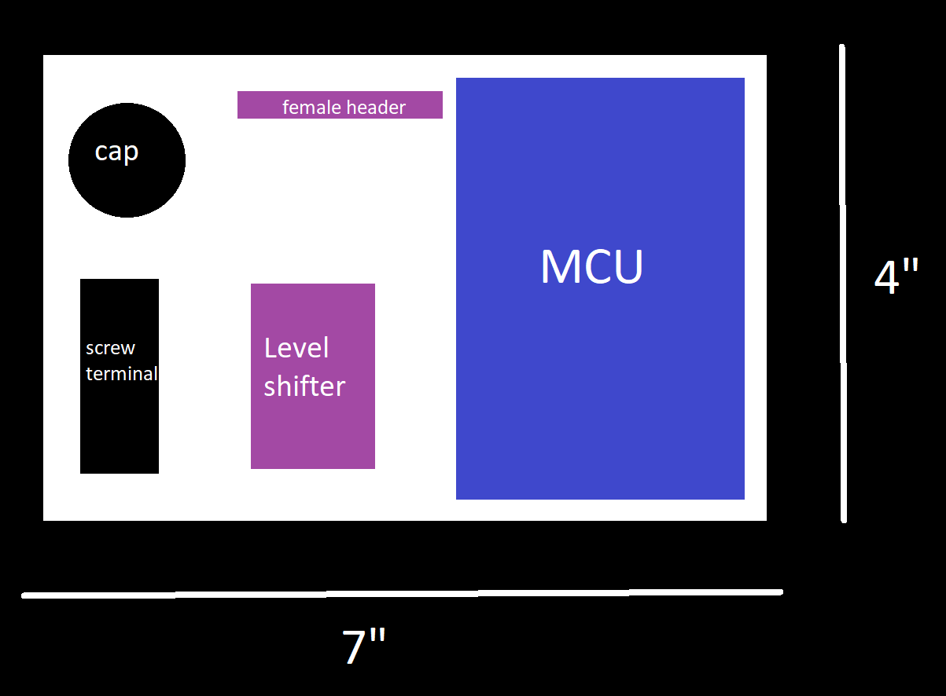

Cap: Decoupling capacitor

Screw terminal: Connecting external power routes to the pcb

Female header: Allows the signals from the Level Shifter to connect to external servo motors.